Kentucky CBA Maps
Louisville, KY-IN
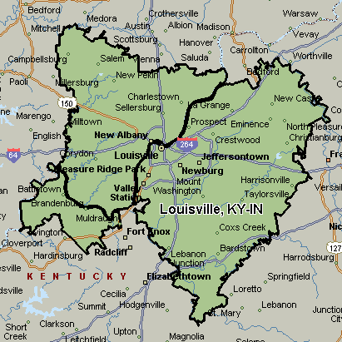

Huntington-Ashland, WV-KY-OH
