Colorado CBA Maps
Denver-Aurora CBA
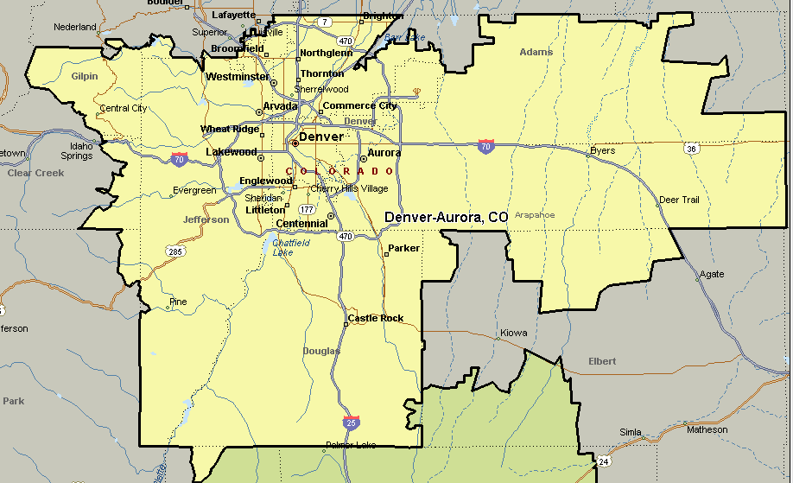
Colorado Springs CBA
