**Sacramento-Roseville-Arden-Arcade, CA**

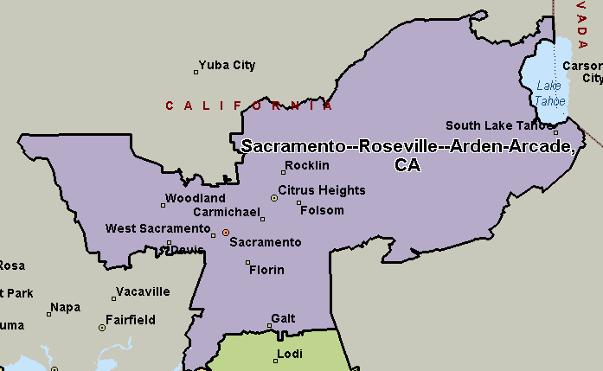

**Stockton-Lodi, CA**

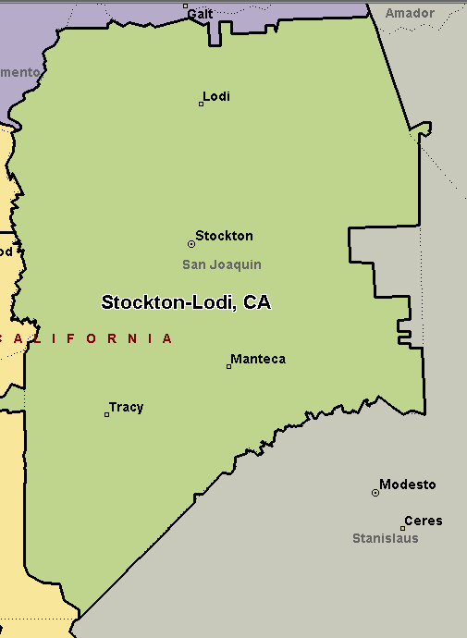

**San Francisco-Oakland-Hayward, CA**

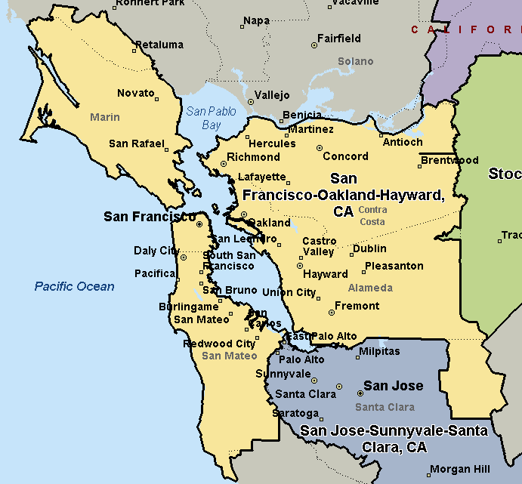

**San Jose-Sunnyvale-Santa Clara, CA**

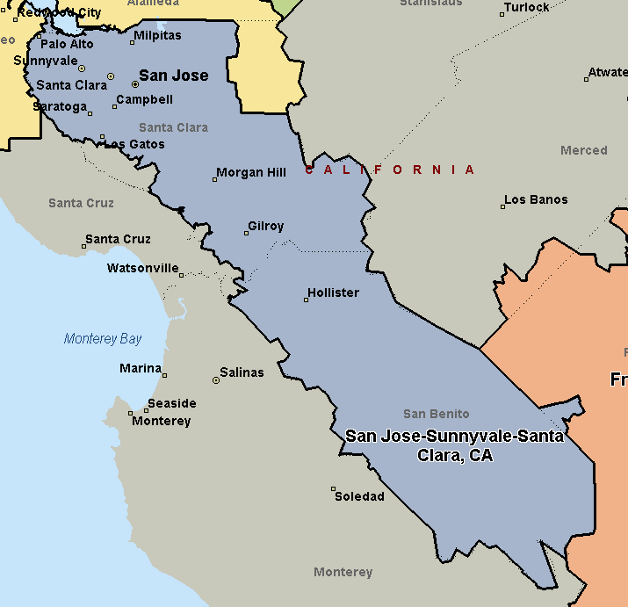

**Fresno, CA**

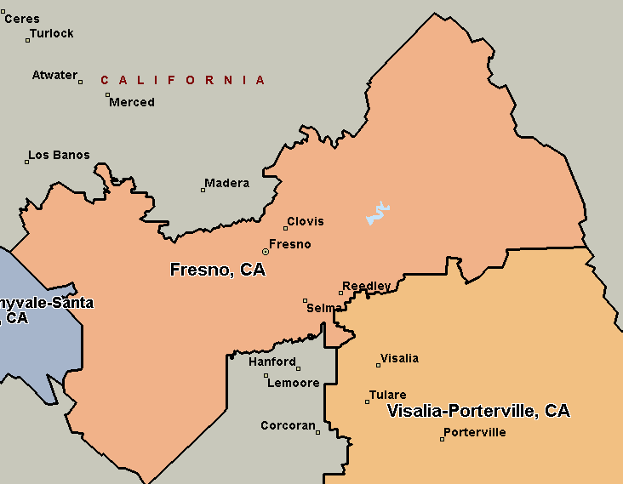

**Visalia-Porterville, CA**

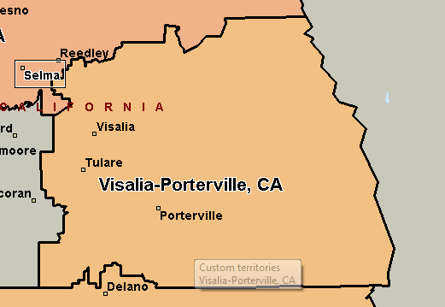

**Bakersfield, CA**

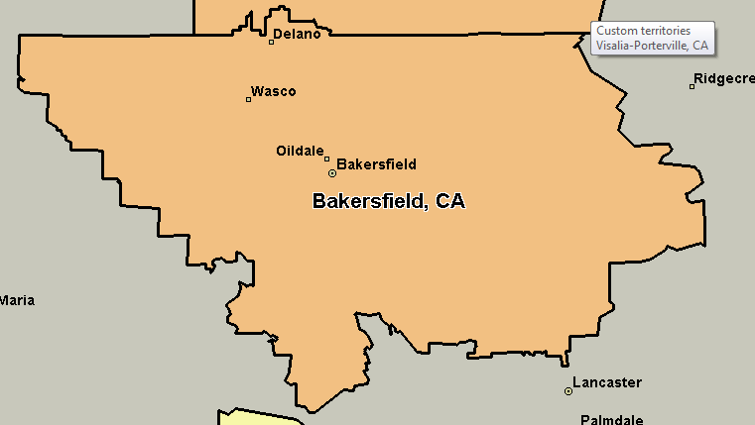

**Oxnard-Thousand Oaks-Ventura, CA**

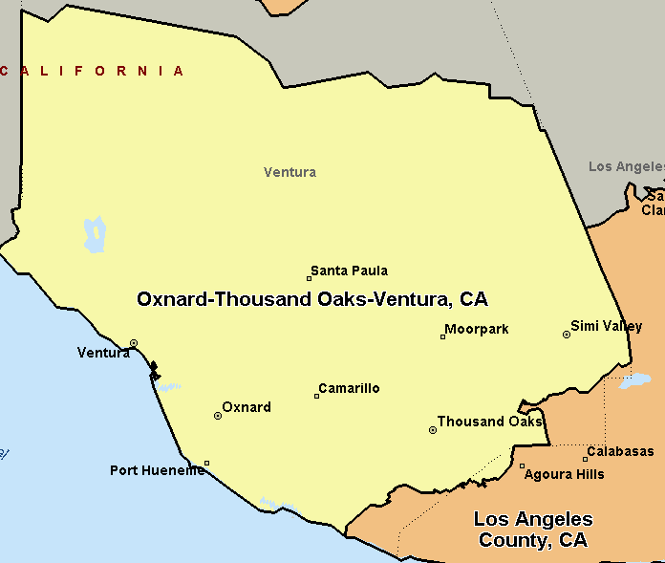

**Los Angeles County, CA**

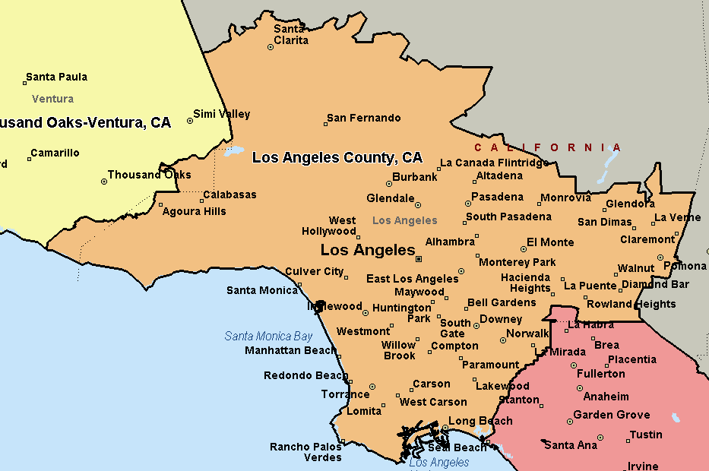

**Orange County, CA**

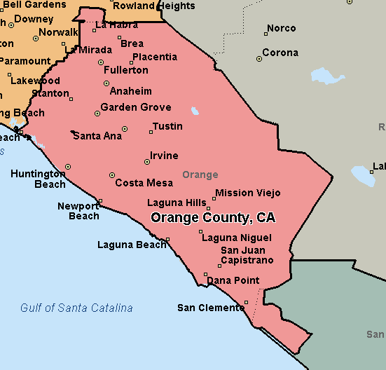

**San Diego-Carlsbad, CA**

