Louisiana CBA Maps
Baton Rouge, LA
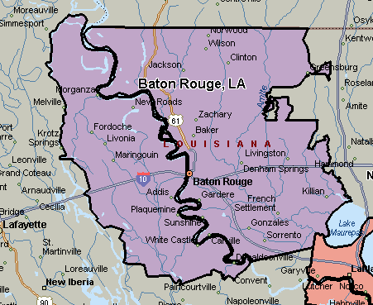

New Orleans-Metairie-Kenner, LA
