Arkansas CBA Maps
Little Rock-North Little Rock, AR
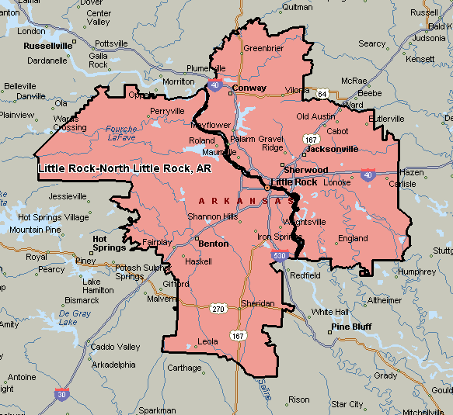

Memphis, TN-MS-AR
