New Jersey CBA Maps
Philadelphia-Camden-Wilmington, PA-NJ-DE-MD
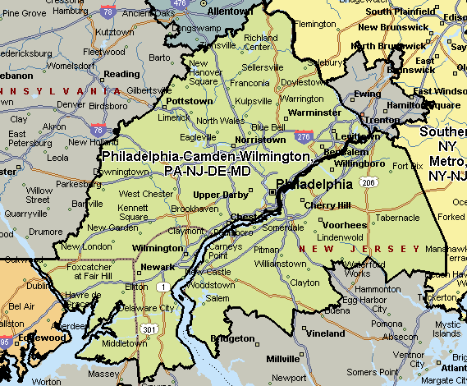

Southern NY Metro, NY-NJ
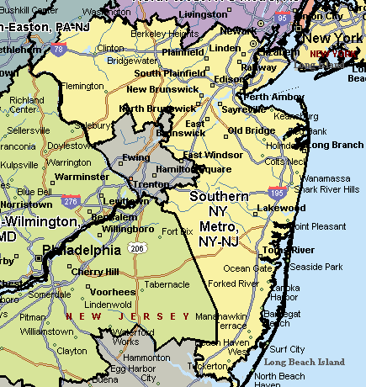

Southern NY Metro-NY-NJ
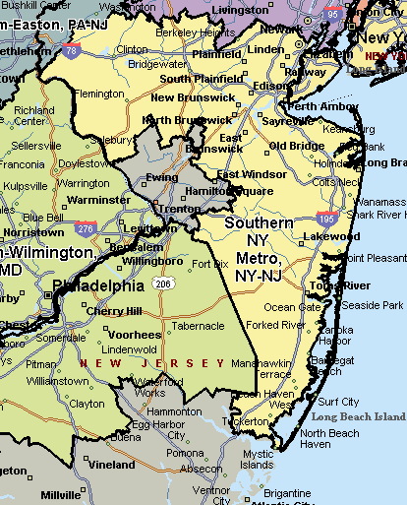

Allentown-Bethlehem-Easton, PA-NJ
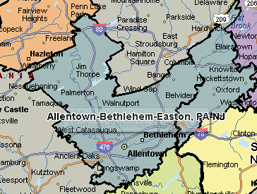
North-West NYC Metro, NJ
