North Carolina CBA Maps
Raleigh-Cary, NC
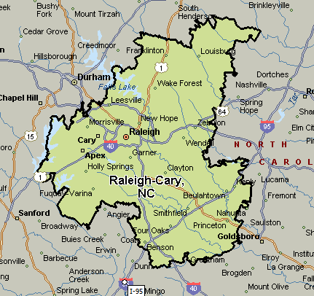
Greensboro-High Point, NC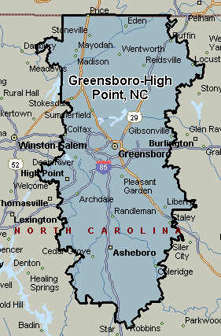
Asheville, NC
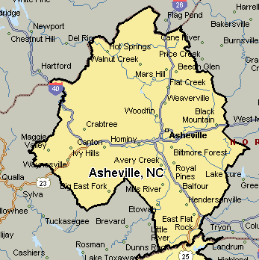
Virginia Beach-Norfolk-Newport News, VA-NC