Pierce & St. Croix Counties, WI
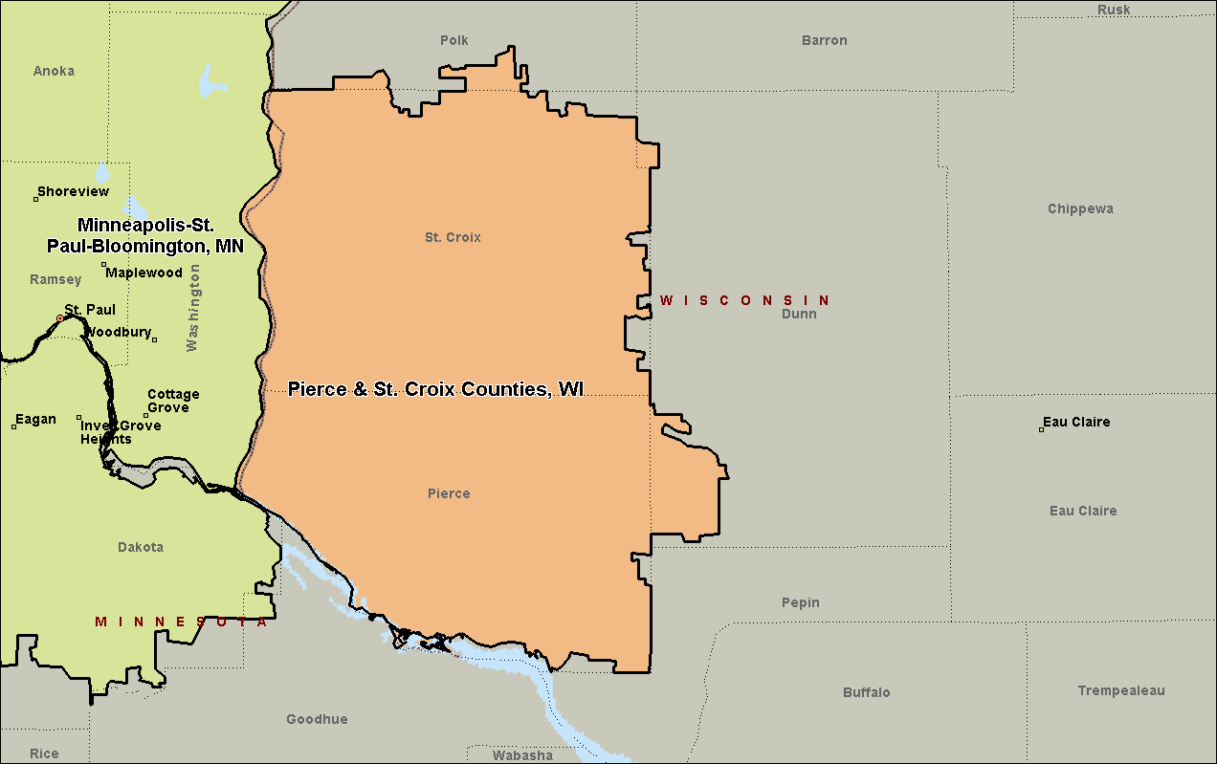

Kenosha County, WI
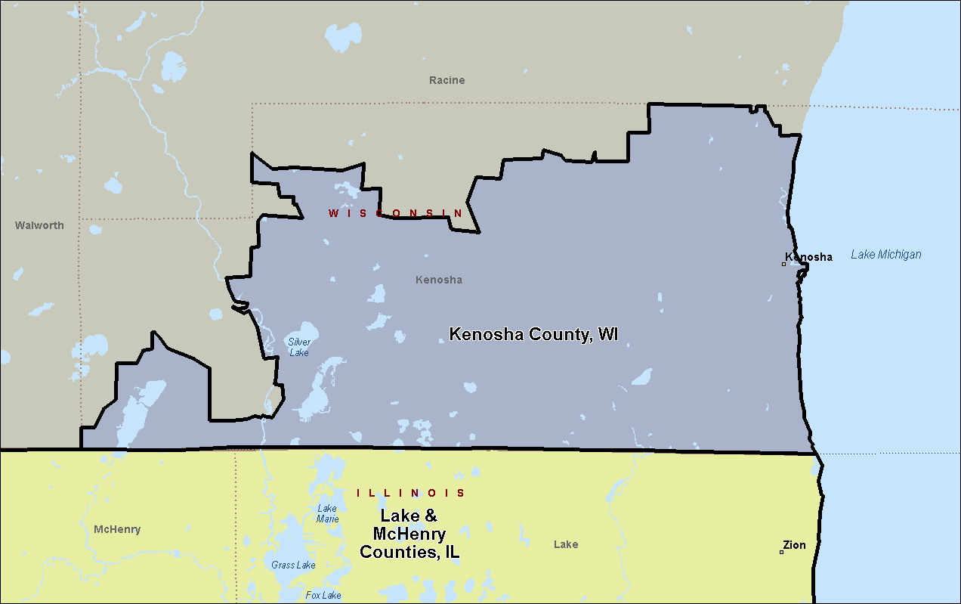

Milwaukee-Waukesha-West Allis, WI
