New York CBAs
Poughkeepsie-Newburgh-Middletown CBA
Northern NYC Metro

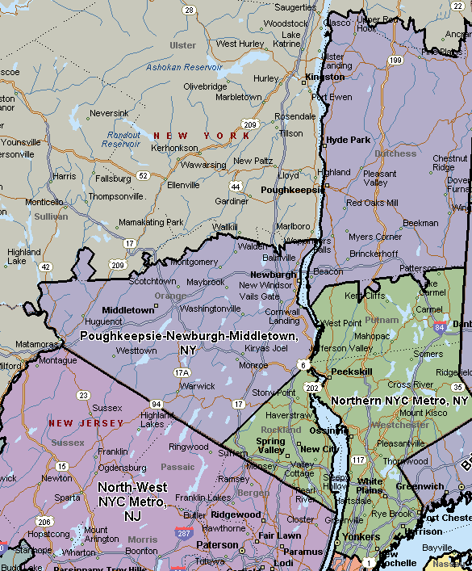

North-West NYC Metro
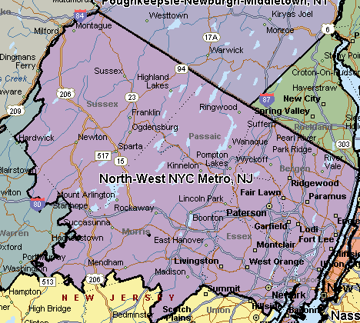
Buffalo-Niagara Falls CBA
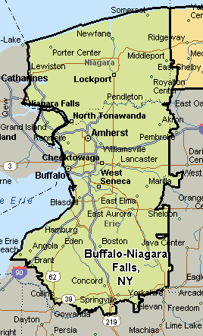
Bronx-Manhattan CBA
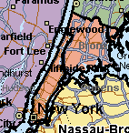

Rochester CBA
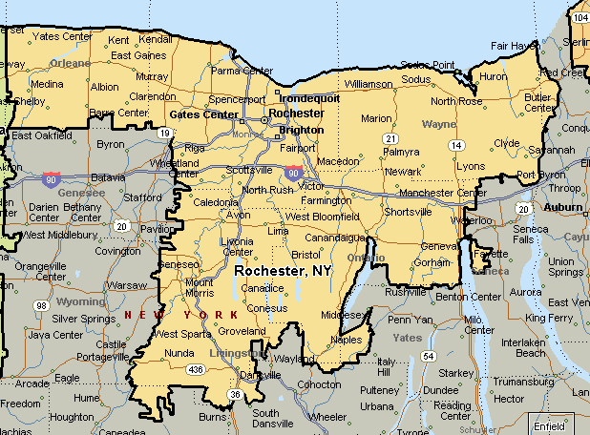

Southern NY Metro, NY-NJ
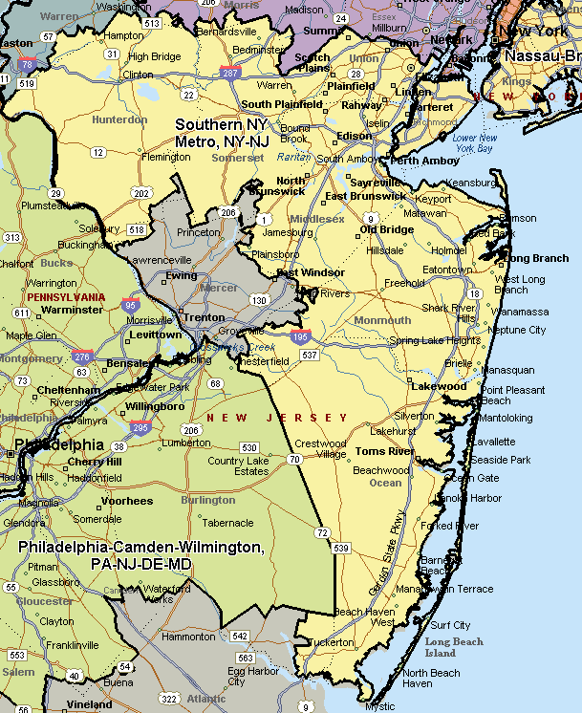

Nassau-Brooklyn Queens CBA
Suffolk County CBA
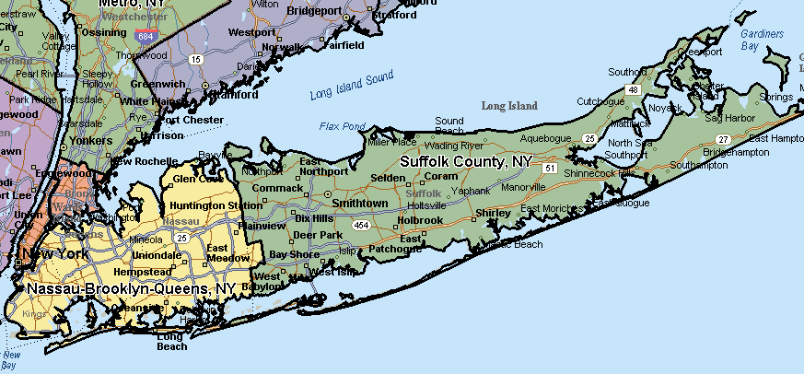
Albany-Schenectady-Troy CBA
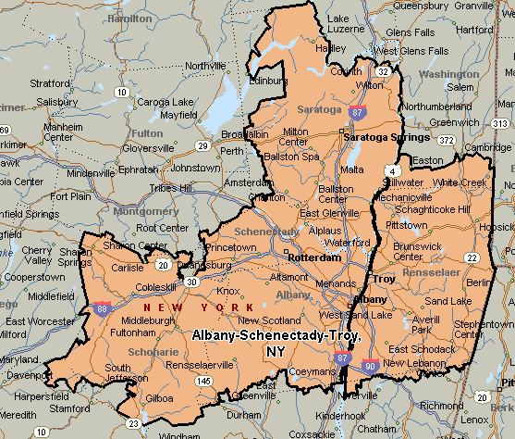

Syracuse CBA
